Dataset Analysis II

(Version J2)

Ankita Dasgupta

J014 Semester III

B.Tech Data Science

1st August, 2020

**Q. For the last 4 months stock market is not performing well because of COVID19. But some analysts are saying that only FMCG sector is performing well. As analyst you must find how this sector (majorly in these five stocks- Dabur India, ITC, United Spirits, HUL, Nestle) is performing in this period.**

**A. Do you think it is worst affected by COVID19?**

**Ans.** We can analyze the dataset with the help of skewness and kurtosis.

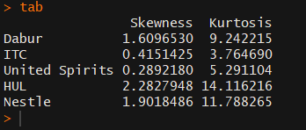

As the value of skewness for all five companies are positive, we can draw the conclusion that the FMCG sector is performing well with respect to other sectors during the four-month period of COVID 19.

Positive skewness tells us that this sector is giving us high positive returns.

Also, as the value of kurtosis for all five companies is greater than three we can assume that the bell curve drown with the help of the dataset of all five companies will be leptokurtic.

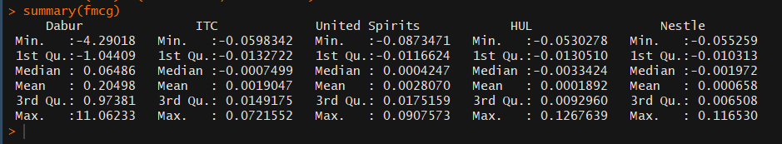

**B. If yes then among the stocks which stock in this sector is the worst performer and why you think so.**

**Ans.** To find the worst performer we must analyses the skewness and find the minimum skewness the company with the most negative skewness gives the least positive returns.

In the case of the five companies, the company with the least skewness is United Spirits with a skewness of 0.289210.

The same conclusion can be drawn with the help of a boxplot and histogram for the United Spirits.

Boxplot for United Spirits:

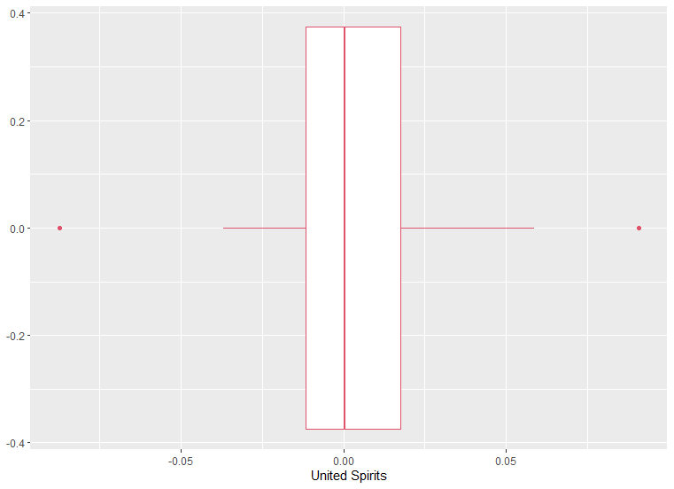

(Q3-Q2)>(Q2-Q1)

Boxplot shows positive skewness

Histogram for United Spirits:

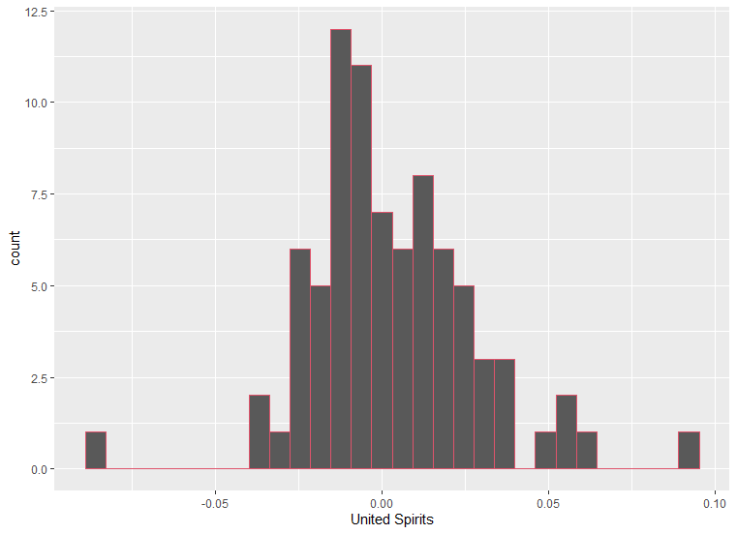

Histogram shows positive skewness with abnormalities.

**C. If No then among the stocks which stocks in this sector is the best performer and why you think so.**

**Ans.** We can compare the returns of the five companies which are performing well with the help of their histograms as well as the values of skewness for each plot.

* Dabur, skewness = 1.6096530

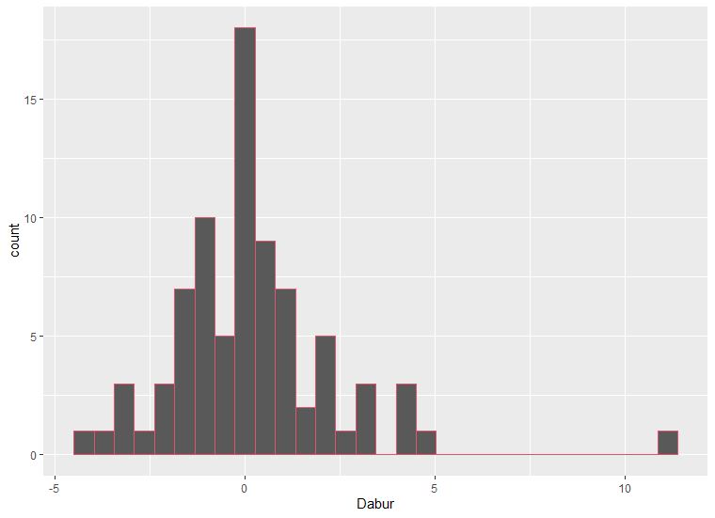

* Nestle, skewness = 1.9018486

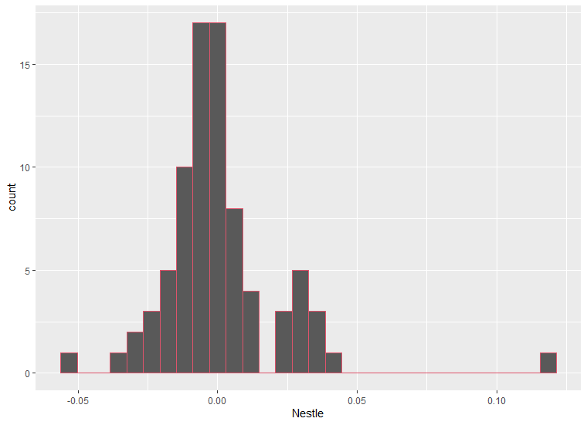

* HUL, skewness = 2.28279486

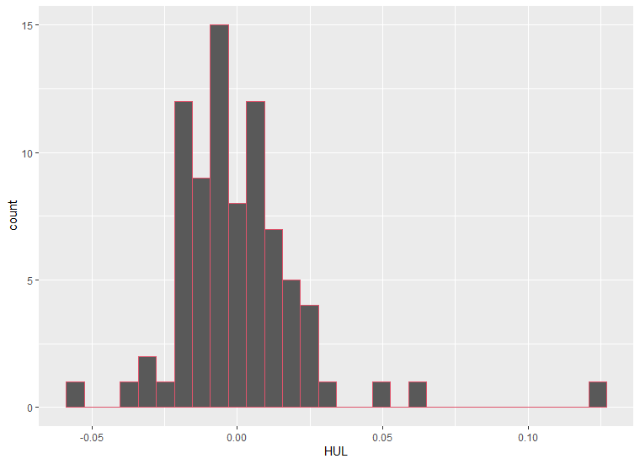

**D. Do think the stocks are correlated with each other?**

**Ans.**

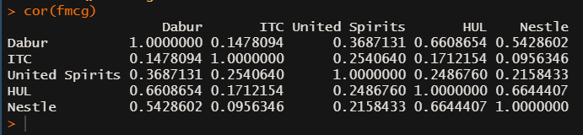

**Scatter Plots:**

**Nestle and hul**

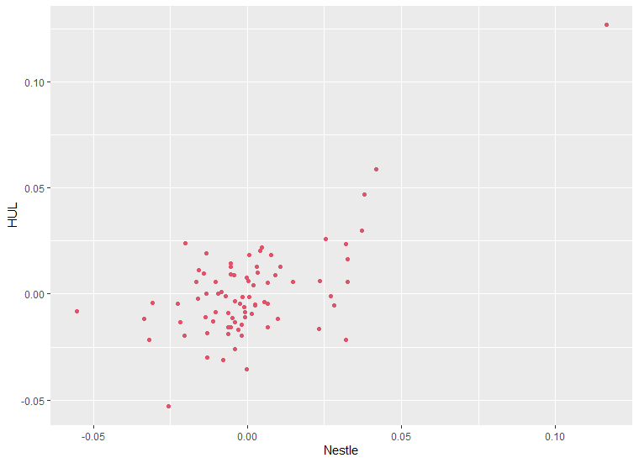

**Hul and dabur**

